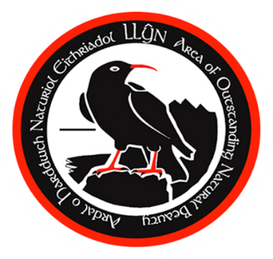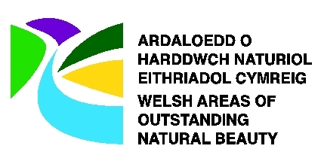

# **SUSTAINABLE DEVELOPMENT FUND**

## **ELECTRONIC APPLICATION FORM**

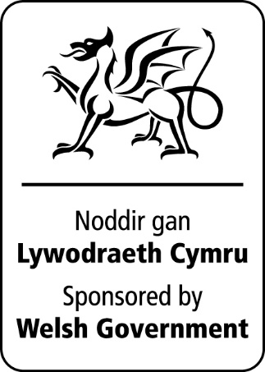

Introduction

This application form is to apply for funds from the **Sustainable Development Fund** which operates in Wales' five Areas of Outstanding Natural Beauty (AONBs)**.**

**Please refer to the guidelines for the scheme** which are there to help you. You are also strongly recommended to discuss your ideas with the AONB project Officer, who will be able to offer advice before you start filling in this form. Details of your local contact are at the end of this form.

### About You

|  |  |
| --- | --- |
| 1. Contact Name |  |
| 2. Name of Organisation |  |
| 3. Contact Address |  |
| Postcode |  |
| 4. Daytime telephone number |  |
| Fax Number |  |
| E-mail address |  |

5. Please provide the following information – tick all boxes that apply:

Voluntary Organisation

Public Sector (including Community Councils)

Registered charity

|  |
| --- |
|  |

*Charity number*

Private individual

Private company / business

|  |
| --- |
|  |

Other (please state)

Does your organisation have a formal constitution? Yes

Does your organisation have a bank account? Yes

Are you registered for VAT? Yes

|  |  |  |  |  |  |  |  |  |  |  |
| --- | --- | --- | --- | --- | --- | --- | --- | --- | --- | --- |
|  |  |  |  |  |  |  |  |  |  |  |

*VAT Number*

**About your project**

|  |
| --- |
|  |

6. Name of project

7. Description of project (Please attach any additional information such as plans, letters of support). **Maximum 250 words.**

|  |
| --- |
|  |

8. Description of project outputs. Who will benefit from the project and how?

**Maximum 250 words.**

|  |
| --- |
|  |

9. How does your project support the Fund's Objectives which are to promote and promote Sustainability and protect and enhance the natural beauty of the AONB?(Please refer to guidelines) **Maximum 200 words**

|  |
| --- |
|  |

10. How will your project satisfy the **core criteria** listed in the guidelines? **Maximum 200 words.**

|  |
| --- |
|  |

11. What other criteria (Environmental, Social, Economic, Cultural) does your project comply with? (See Guidelines). **Maximum 200 words.**

|  |
| --- |
|  |

12. Is there a business plan or other plan / strategy for the project (Attach / give details).

|  |
| --- |
|  |

13. Have you obtained all the permissions required to start the project? (e.g. planning permission, ownership of site etc). Please state what is needed and when it will be agreed and attach a copy of any permissions already obtained.

|  |
| --- |
|  |

14. Is the project targeted towards benefiting or involving any particular groups of people e.g. young people, less-abled? If so please provide details. **Maximum 150 words.**

|  |
| --- |
|  |

15. How will the project help deliver the AONB Management Plan or other projects / strategies (e.g. Community Strategies)? **Maximum 150 words.**

|  |
| --- |
|  |

16. Does the project link to other schemes (e.g. local regeneration scheme)? **Maximum 150 words.**

|  |
| --- |
|  |

17. How will the project help generate private or voluntary sector investment? **Maximum 100 words.**

|  |
| --- |
|  |

18. Who will maintain the completed project and how will this be funded in future? **Maximum 100 words.**

|  |
| --- |
|  |

19. How will you measure the success of the project and promote the SDF contribution? **Maximum 100 words.**

|  |
| --- |
|  |

20. Location of project – with Ordnance Survey Grid Reference (if applicable).

|  |
| --- |
|  |

21. Timetable for project

|  |  |
| --- | --- |
| Likely start date (MM/YYYY) |  |
| Likely end date (MM/YYYY) |  |

22. Please list your partners, and briefly specify their involvement in the project.

|  |
| --- |
|  |

### Project budget

23. Outline the cost of the project broken down into its components (e.g. purchase of equipment or staff costs etc) and show where VAT is included with an asterisk *.

**(A)** **Project Costs**

|  |  |  |  |  |
| --- | --- | --- | --- | --- |
|  | **In kind or cash?** | **Year 1**  **Cost** | **Year 2**  **Cost** | **Year 3**  **Cost** |
|  |  |  |  |  |
|  |  |  |  |  |
|  |  |  |  |  |
|  |  |  |  |  |
|  |  |  |  |  |
|  |  |  |  |  |
|  |  |  |  |  |
|  |  |  |  |  |
|  |  |  |  |  |
|  |  |  |  |  |
| Total cost of project |  |  |  |  |

##### 24. Sources of income and funding sought from partners. Please show where VAT is included with an asterisk *.

##### (B) Project Income

|  |  |  |  |  |  |  |  |
| --- | --- | --- | --- | --- | --- | --- | --- |
|  | **In kind or Cash?** | **Year 1**  **Income** | | **Year 2**  **Income** | | **Year 3**  **Income** | |
|  |  | **Amount** | **% of total** | **Amount** | **%of total** | **Amount** | **% of total** |
| SDF Funding | Cash |  |  |  |  |  |  |
|  |  |  |  |  |  |  |  |
|  |  |  |  |  |  |  |  |
|  |  |  |  |  |  |  |  |
|  |  |  |  |  |  |  |  |
|  |  |  |  |  |  |  |  |
|  |  |  |  |  |  |  |  |
|  |  |  |  |  |  |  |  |
|  |  |  |  |  |  |  |  |
|  |  |  |  |  |  |  |  |
| Total income of project |  |  |  |  |  |  |  |

Please read and sign the following statement:

“*I certify that all the information provided in this application is true to the best of my knowledge. I understand that any misleading statements whether deliberate or accidental could make the application invalid and therefore liable for the return of any money*.”

|  |
| --- |
|  |

Full name

|  |
| --- |
|  |

Date (DD/MM/YYYY)

**Please enclose any supporting information**

**with your application.**

##### Contact Details

Please return this completed application form to:

|  |
| --- |
| Llŷn AONB Unit  Gwynedd Council Offices  Ffordd y Cob  Pwllheli  Gwynedd  LL53 5AA  ahnellynaonb@gwynedd.gov.uk |

The Sustainable Development Fund is delivered locally through your

Local Authority AONB and co-ordinated by the Natural Resources Wales

on behalf of Welsh Government.

###### For office use only

|  |  |
| --- | --- |
| Application form number: |  |
| Returned application reference: |  |
| Date form received: |  |
| Date received all necessary information to enable application to be assessed: |  |

|  |
| --- |
|  |

Natural Resources Wales, Maes Y Ffynnon, Ffordd Penrhos,

Bangor, Gwynedd, LL57 2DW. Tel: 0300 065 3000